
MATHS METHODS (CAS) 3 & 4
TRIAL EXAMINATION 2
SOLUTIONS
2015

SECTION 1 – Multiple-choice answers
- E 9. D 17. A
- C 10. C 18. D
- E 11. E 19. E
- A 12. D 20. C
- B 13. D 21. B
- C 14. D 22. C
- D 15. D
- B 16. E

SECTION 1 – Multiple-choice solutions
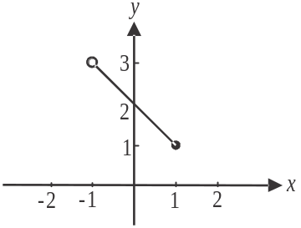

Question 1

Do a quick sketch.
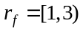
The answer is E.

Question 2

The maximal domain occurs when 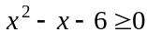 since the square root of a negative number is undefined for .
Solve for x.
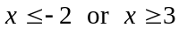
In interval notation, this is expressed as 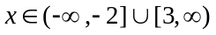.
The answer is C.

Question 3

Method 1 - intuitively
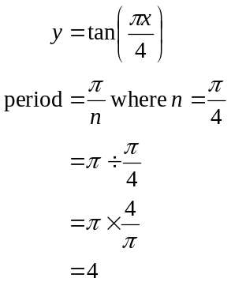
The graph of this function is dilated by a factor of 2 from the y-axis, that is, it is stretched horizontally by a factor of 2, so its period will be 8.
The answer is E.
Method 2 – algebraically
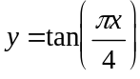
The graph of this function is dilated by a factor of 2 from the y-axis, so replace x with in the equation.
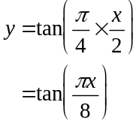
The period of this transformed function is
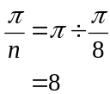
The answer is E.

Question 4

The period of the graph is . Since the period is 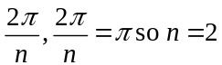.
The shape of the graph is that of an inverted cos graph that has been translated 1 unit down so the rule could be 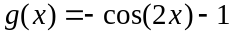.
The answer is A.

Question 5

Do a quick sketch of a possible graph.
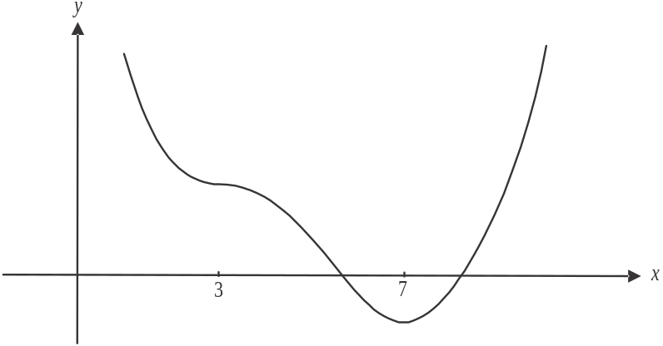

There is a stationary point of inflection at . Note that there could be an x-intercept at if the graph shown was translated vertically up but there doesn’t have to be.
The answer is B.
Question 6
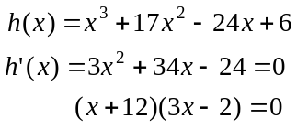
Stationary points occur at 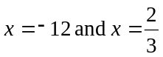.
Do a quick sketch.
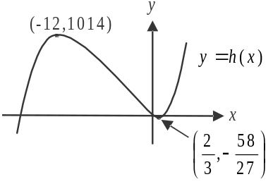

An inverse will exist if h is a function.
This will only occur if 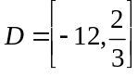
The answer is C.

Question 7

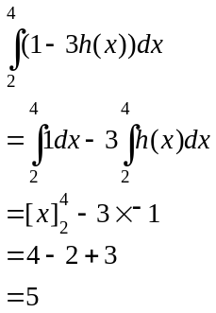
The answer is D.

Question 8
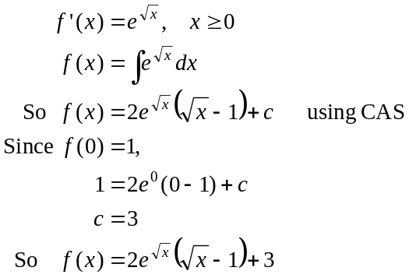
The answer is B.

Question 9

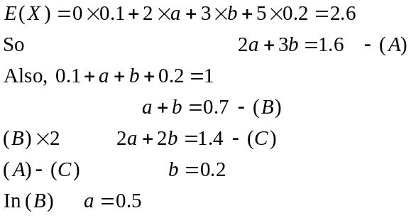
The answer is D.
Question 10

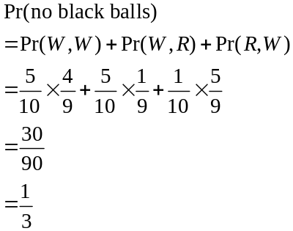
The answer is C.

Question 11

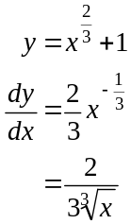
When 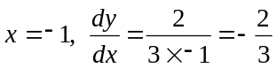.
So the gradient of the tangent is 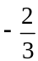 and the gradient of the normal is therefore .
Equation of normal:
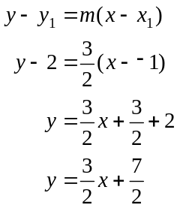
The y-intercept is .
The answer is E.

Question 12

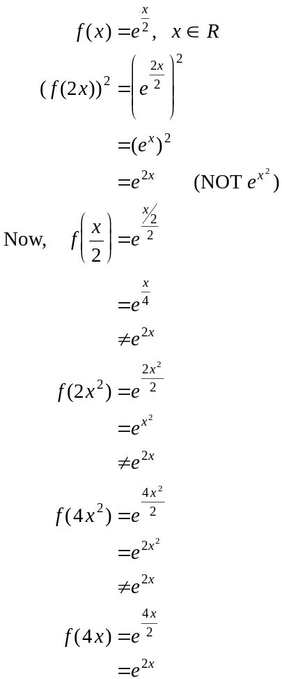
So option D is correct.
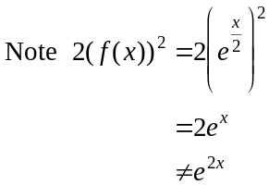
The answer is D.

Question 13

Since A and B are independent events,
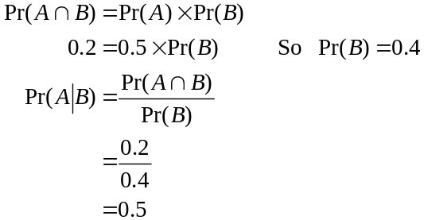
The answer is D.

Question 14

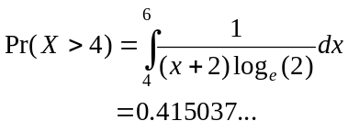
The closest answer is 0.4150.
The answer is D.

Question 15

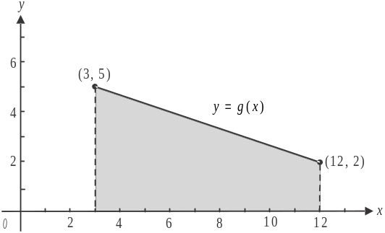
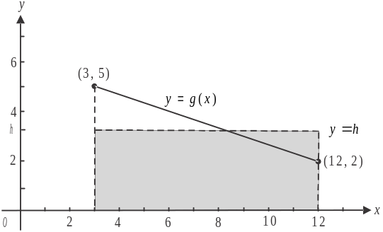

The two shaded regions shown in the two diagrams above are equal in area. The average value of g is h, as indicated in the second diagram.
We want to find h.
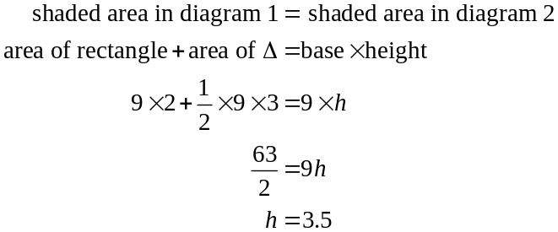
The answer is D.

Question 16

Do a quick sketch.
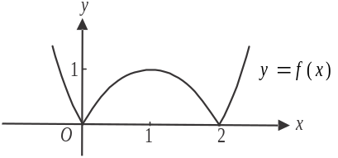
For f, 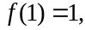 the graph is continuous for ,
and the gradient is positive for .
At , the graph has a sharp point; that is,
it is not smoothly continuous and therefore is
not differentiable at these points. Option E is not true.
The answer is E.

Question 17
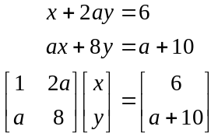
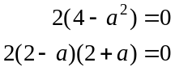

If , we have
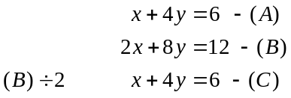
Since (A) and (C) are the same line, there are infinitely many solutions for .
If , we have
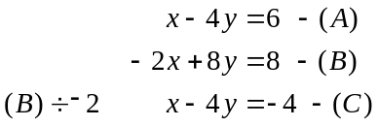
Since the lines given by (A) and (C) are parallel, there can be no solutions.
So there are infinitely many solutions only when .
The answer is A.

Question 18
Do a quick sketch.
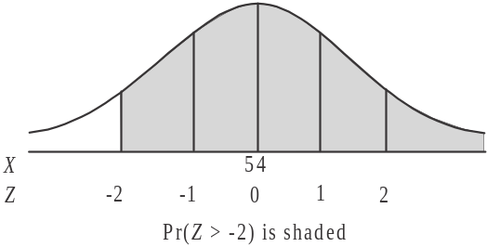
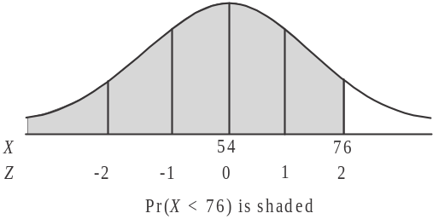

Since 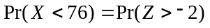, then 76 must lie two standard deviations above the mean.
Now so the standard deviation is 11. So the variance of X equals 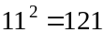.
The answer is D.

Question 19
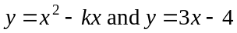
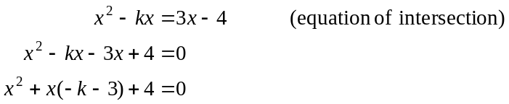
The graphs intersect at two distinct points when .
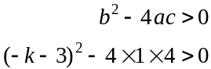
Solve this inequation for k using CAS 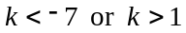.
The answer is E.

Question 20

Since area of 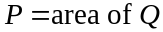,
solve 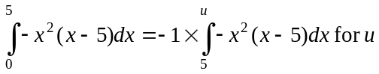.
Note that the x-intercepts of the graph of f occur at . Also, since area Q falls below the x-axis, we need to multiply the integral 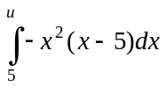 by negative one to obtain the actual area.
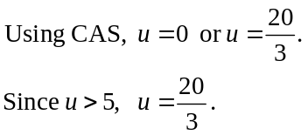
The answer is C.

Question 21

The relationship 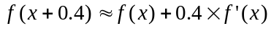 is an application of the approximation formula .
To approximate 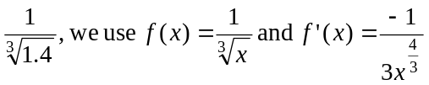
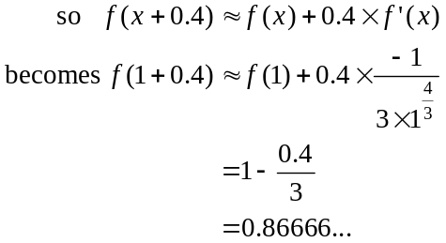
The approximation is 0.8667
The answer is B.

Question 22

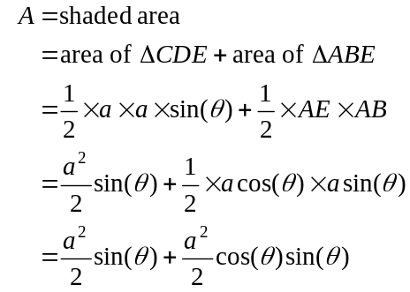
Solve 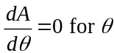 using CAS
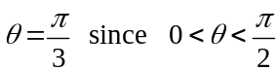
The answer is C.

SECTION 2

Question 1 (6 marks)

- At midnight on Sunday .
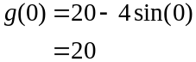
The temperature is 20C at midnight on Sunday.
(1 mark)

- 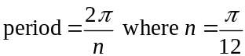
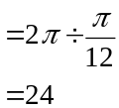
(1 mark)

- Since the amplitude is 4, the maximum temperature is 24C. (1 mark)
The average temperature is 20C. (1 mark)

- Solve 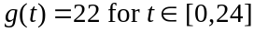
(1 mark)
A quick sketch of the graph of 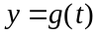 shows that the temperature inside the greenhouse is above 22C for 8 hours a day between .
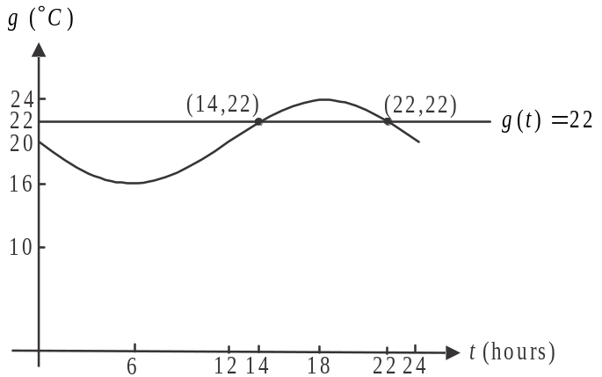

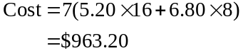
(1 mark)

Question 2 (15 marks)

- 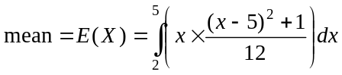
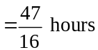
(1 mark)

- Solve 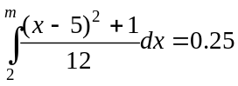 for m. (1 mark)
The maximum time was 2.332 hours (correct to 3 decimal places).
(1 mark)

- 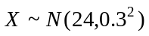
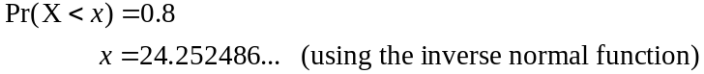
Filters with a maximum diameter of 24.25mm (correct to 2 decimal places) can be used in a Mini car.
(1 mark)

- 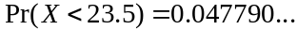 (using the normal cdf function)
(1 mark)
So 33 of the filters will fit in any car (to the nearest whole number)
(1 mark)

- i. Method 1 – using transition matrices

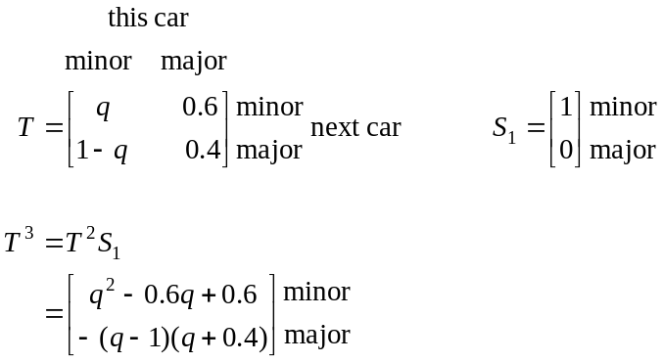
(1 mark)
The required probability is
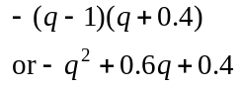
(1 mark)

Method 2 – using a tree diagram
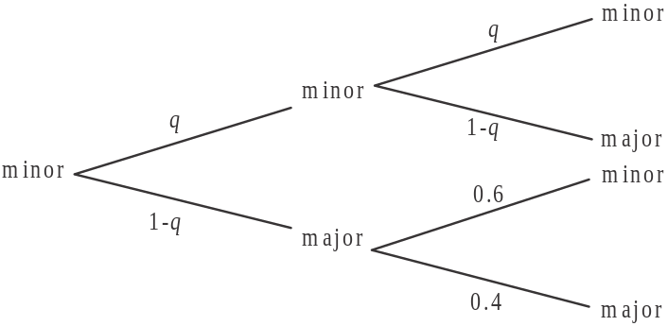

(1 mark)

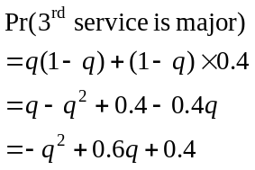
(1 mark)
(1 mark)
  - Solve 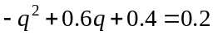
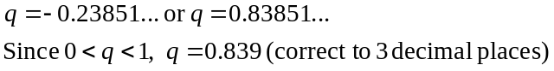
(1 mark)

  - 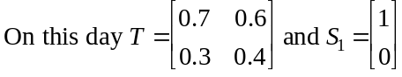
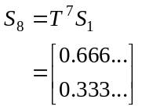
(1 mark)
The probability that the last car had a minor service was .
(1 mark)

- i. Solve 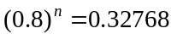 for n
(1 mark)
- This is a conditional probability question.
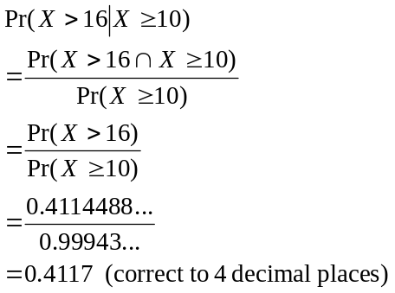
(1 mark)
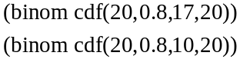
(1 mark)

Question 3 (11 marks)

- From the diagram, we see that the maximum height occurs at the back wall of the bay where .
So 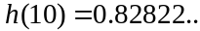
Height is 0.83m (correct to 2 decimal places).
(1 mark)

- Solve 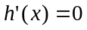 for x. (1 mark)
So the interval required is 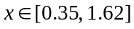 where the endpoints are expressed correct to 2 decimal places.
(1 mark)

- Solve 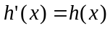 for x. (1 mark)
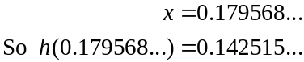
The height is 0.14 metres (correct to 2 decimal places).
(1 mark)

- Since the average rate of change of h between .
Solve 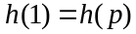 for p. (1 mark)
Since .
(1 mark)

e. 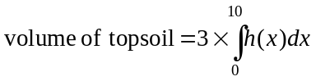 (1 mark)
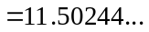
The estimate for the volume of topsoil is 11.50 cubic metres (correct to 2 decimal places).
(1 mark)

f. We are looking for the average value of the function h over the interval 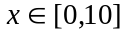.
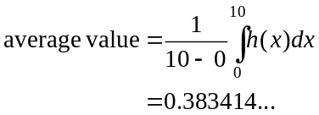
(1 mark)
The height of the top soil would be 0.38 metres (correct to 2 decimal places).
(1 mark)
Question 4 (12 marks)

- 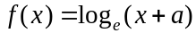
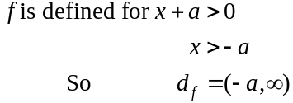
(1 mark)

- i. x-intercepts occur when 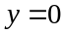
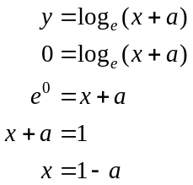
If the x-intercept is negative
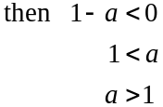
(1 mark)

- From part i. the x-intercept occurs when .
If the x-intercept is positive then
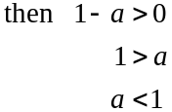
Also, we are told in the question that a is positive so .
(1 mark)

- i. Given 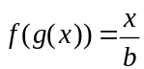
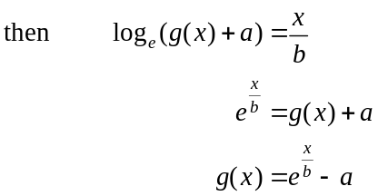
as required.
(1 mark)

  - 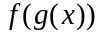 is a composite function and 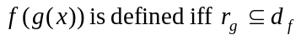
Now 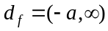 from part a.
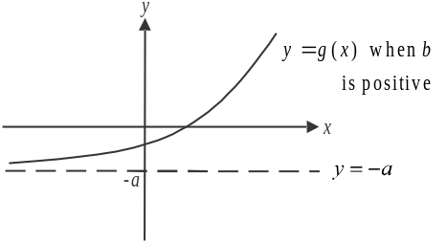
To find the range of , do a quick sketch.
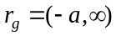

Since 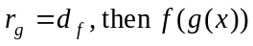 is defined.

(1 mark)
- i.
Let 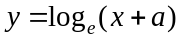
Swap x and y for inverse.
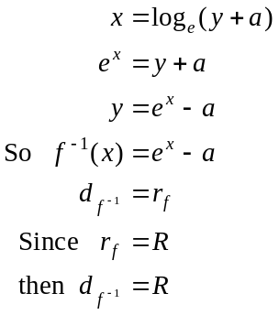
(1 mark)
(1 mark)
  - Since 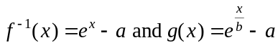, the transformation required to transform the graph of 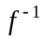 to the graph of g is a dilation from the y-axis by a factor of b units.
(1 mark)

- Since , the x-intercept of the graph of f will be negative from part b. i.
Do a quick sketch.
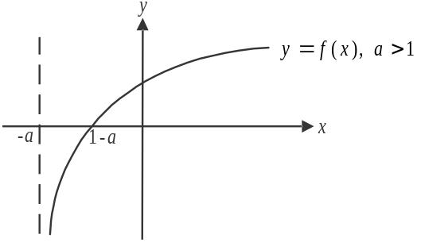

The x-intercept occurs at from part b. so
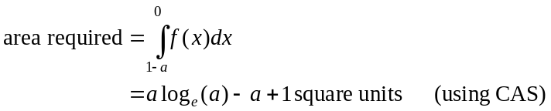
(1 mark) – correct integrand
(1 mark) correct terminals
(1 mark) correct answer

- From part b, if the graph of f has
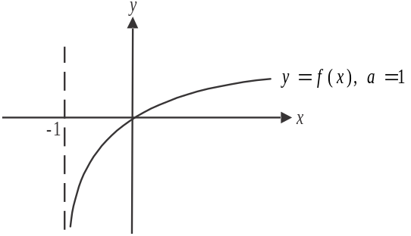
a negative x-intercept and if ,
the graph of f has a positive x-intercept.

When , the graph of f passes through
the origin hence the area enclosed by the
graph of 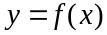 and the x and y axes
equals zero.
Alternatively, there is no area enclosed
by the graph of and the x and y
axes.
(1 mark)
Question 5 (14 marks)

- The height of the land above sea level on the island, as seen from the naval ship is given by the function l. Define this function on your CAS.
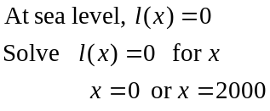
So the width of the island as observed from the naval ship is 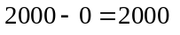metres.
(1 mark)

- Find 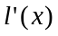.
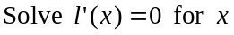
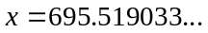 (1 mark)
Substitute this value into 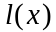.
The highest point on the island occurs at the point 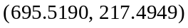 where coordinates are expressed correct to 4 decimal places.
(1 mark)

- i. 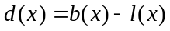
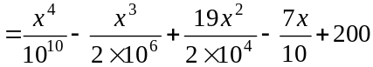
(1 mark)

  - 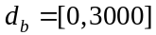
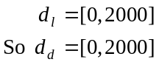
(1 mark)

- Define 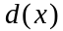 (if you haven’t already) on your CAS using your answer to part c. i.
Find 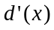
Solve 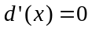 for x
(1 mark)
Substitute this into .
The minimum vertical distance between the balloon and the land is 26.78m (correct to 2 decimal places).
(1 mark)
- Find .
Substitute 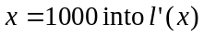.
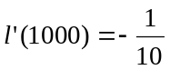
(1 mark)
The equation of the tangent has a gradient of 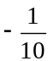 and passes through 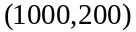.
The equation is given by
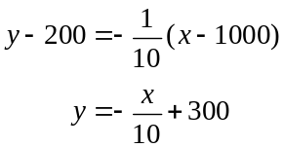
(1 mark)
- The missile crosses the flight path of the balloon when 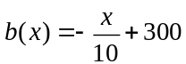.
Solve this equation for x.
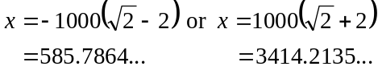
Since , we reject this second value of x.
So 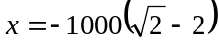. (1 mark)
Note that the numerical values here are used only to see whether the values of x are feasible. Since we have not been asked for decimal approximations in the question, we must use the exact values of the coordinates.
Substitute 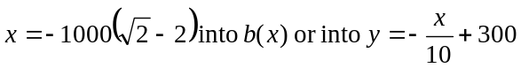.
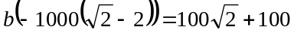
The missile crosses the flight path of the balloon at the point 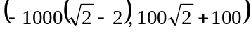
(1 mark)
g.
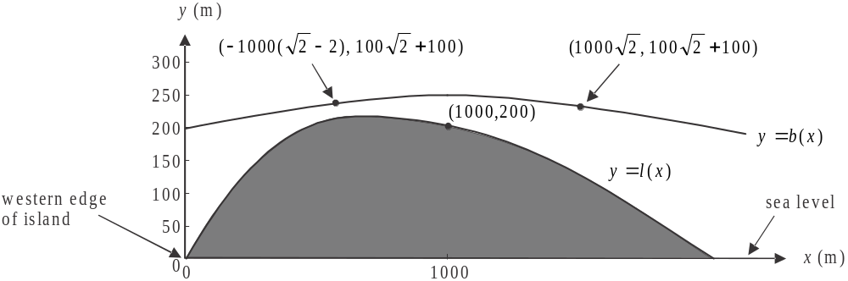

To find the location of the balloon when the enemy missile crosses the flight path of the balloon, solve 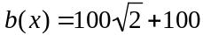 for x.
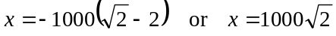.
The balloon is located at the point 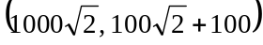. (1 mark)
At this instant, Victoria fires a missile to hit the point (1000, 200).

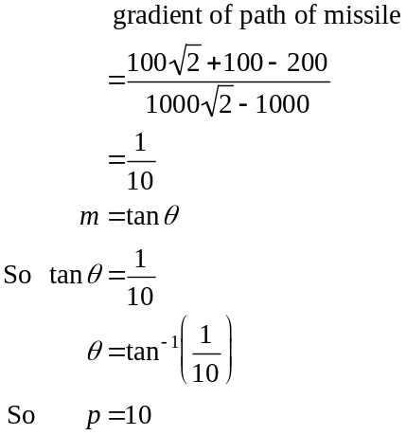
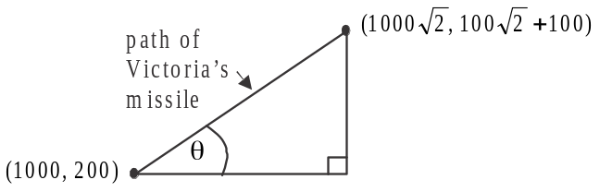
(1 mark)
(1 mark)

